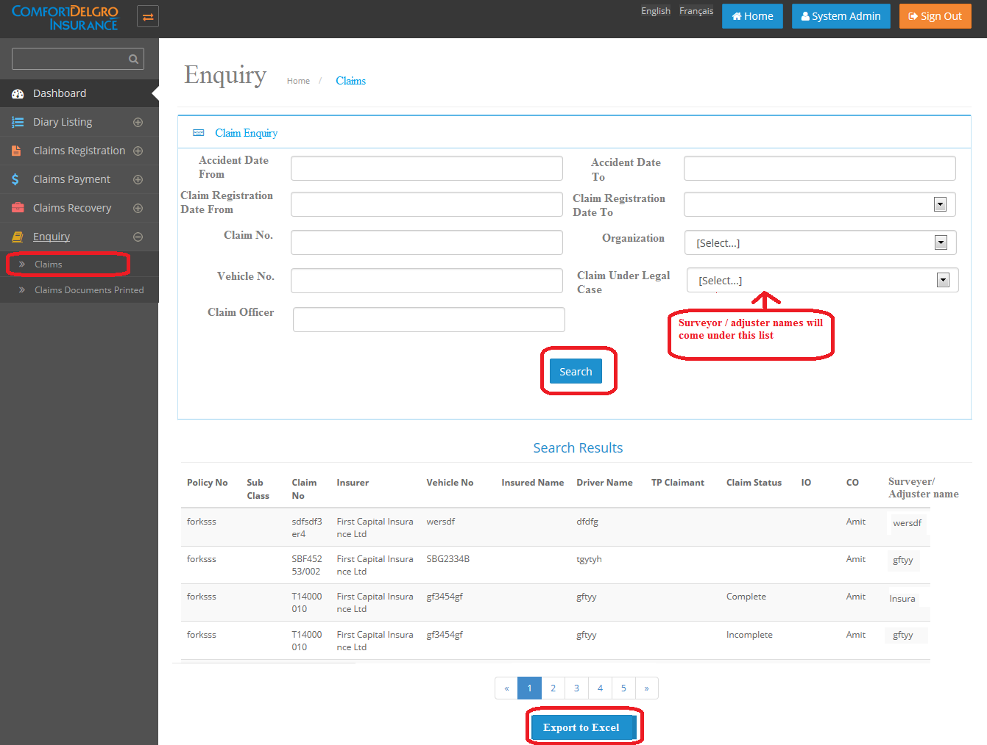

Consistent font please. This button appears after Search Result. If no claims data selected from Search criteria, display “ No Claims found matching criteria selected”

Excel file must show search criteria selected to generate this report

Dropdown are claims under Legal cases. Source are claims where – a) Claim Tab has Lawyer Appointed (b) in Third Party tab – Third Party Lawyer field is completed

This field has nothing to do with Surveyor/Adjuster

Drop down – have smart search – user can key in a few chars and system will filter. Otherwise, dropdown listing is too huge

Drop down list in ascending order

Calendar

Please ensure consistent fonts and size